Running image processing script on server

# Installation

1. First, you need to download the models and scripts by downloading all files at this [link](https://drive.google.com/file/d/1hlOK9f3M4e_Dv9F2MaXjIoH3_cblHzQz/view?usp=sharing)into your computer. Keep all files into a single zip folder. Then proceed with the installation instructions below.
2. Open PowerShell in Windows, or terminal in Mac:

**Note from Jessie: You can also use a program like CyberDuck to make it easier to upload the .zip file onto the server. Proceed to step 7 if you do so.**

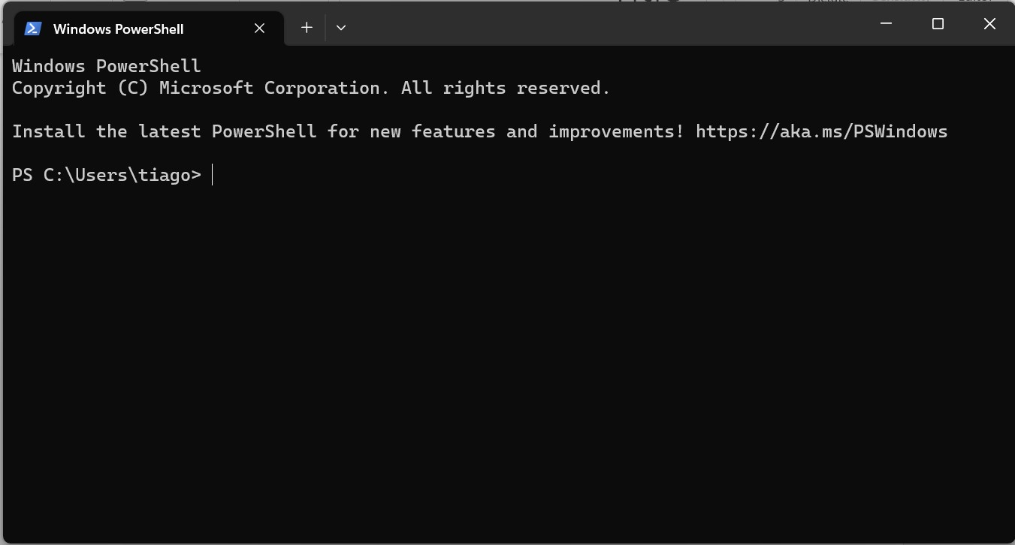

1. Copy the address of the zip folder you just downloaded. Mine is

"C:\Users\tiago\Downloads\models-20230808T141536Z-001.zip"

1. On the terminal, write the following “scp <file address> <USERNAME>@ symbiont.eeb.utoronto.ca:”

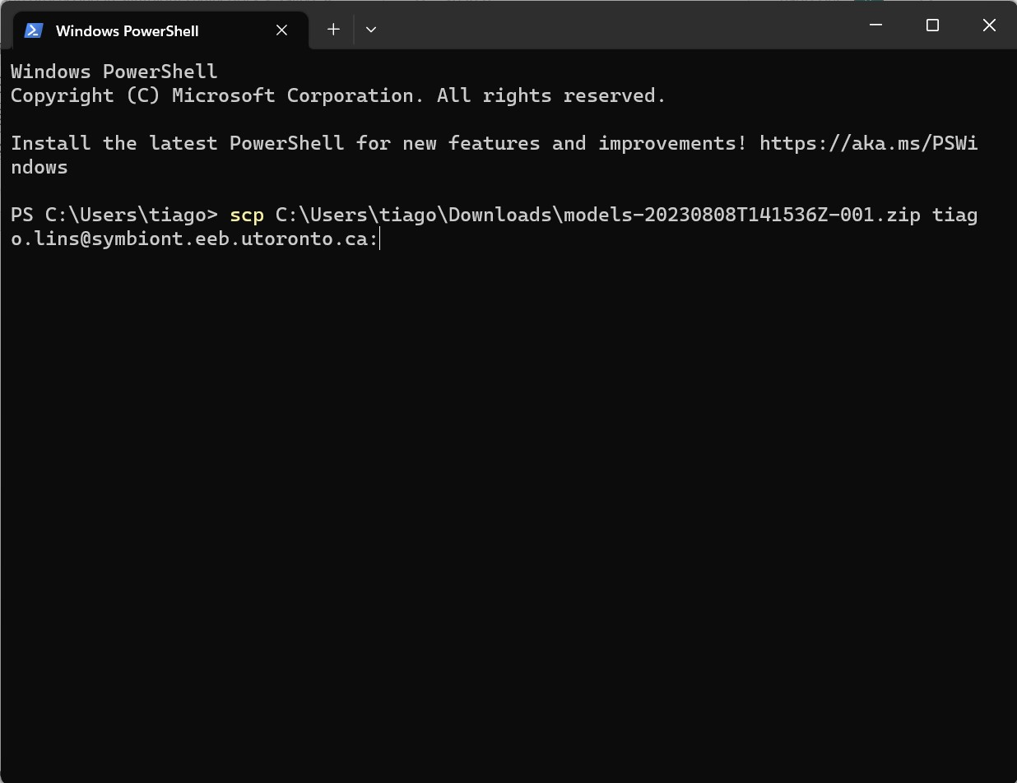

1. Enter your password when prompted
2. Wait until the file is uploaded

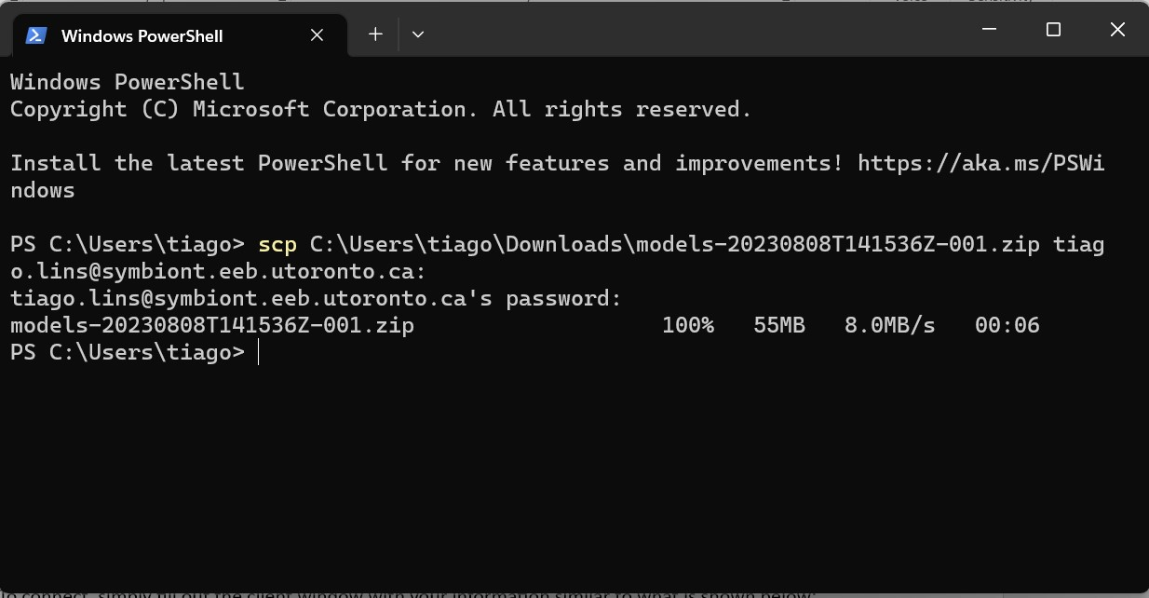

1. Now connect to the server “ssh <USERNAME>@ symbiont.eeb.utoronto.ca”
2. Enter password when prompted
3. Once connected, type “unzip <file name> -d models” to unzip the contents of the folder



You will only need to do installation once. Now you can run the script following the instructions below.

# Running script

1. Now, activate the environment by typing “cd /symbiont/apps/miniconda3/condabin/”
2. Then write “conda activate TF1”
3. The environment is now activated (you will see *TF1* instead of *base* in every line):



1. Now type “cd” command
2. Then “cd models/models” to access the models and scripts for processing the images
3. Then type “python run_all_files.py” to run the script



1. Several warnings will show up. Wait until prompted to provide input
2. You will be asked the following questions. Enter the answer one by one as follows:

* Please enter the directory name: [enter the path of where the image are stored in the server. For me, it is /symbiont/tiago.lins/cameraA]
* Please enter the start date as yyyymmdd-hhmmss (i.e. 20230705-100000 for July 5th, 2023 at 10 am): [Each image file should have a date on its name. Enter the earliest date you want to be processed using a format like this: 20220801-100000]
* Please enter the end date as yyyymmdd-hhmmss (i.e. 20230705-120000 for July 12th, 2023 at 10 am): Enter the latest date you want to be processed using a format like this: 20230301100000]
* Override plate identifier? (No, 96, 24, 12, 6): [In case you want the script to identify the plate type, write “no”; otherwise write the desired plate type. Note that 12 is not yet supported]
* Modify images before processing them? (Yes, No): [If you need to adjust the images where a plate is not lined up in the middle, or indicate if there is/what type of plate on either side] Type "Yes" to use the csv file with the shifts and plate ids. Then you can input the location of the file in the next question.

**Example:**

**Additional notes from Tiago (11/19/2023):**

As it runs, It will update a full_data.csv file, which you can download anytime:

It should read the shifts and apply them:

It will also save files titled "mask_plate#.png", for checking how the masking is performing:

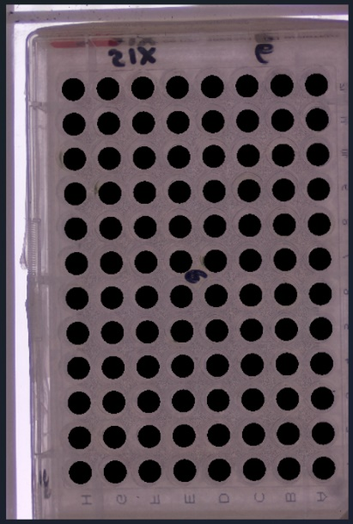

9. Once completed, hit enter/return key and wait as the script processes the images. A **data** folder will be created on the same directory as the images being processed. Within the data folder, there will be a **data_<date_start>_to_< date_end>** folder with the results for your run. To navigate through these directories, use “cd <directory>”, “ls” commands to go to a new directory and to view the content in a directory, respectively. Alternatively, you can also use Bitvise (Windows only) to view the content in the server, as shown below:

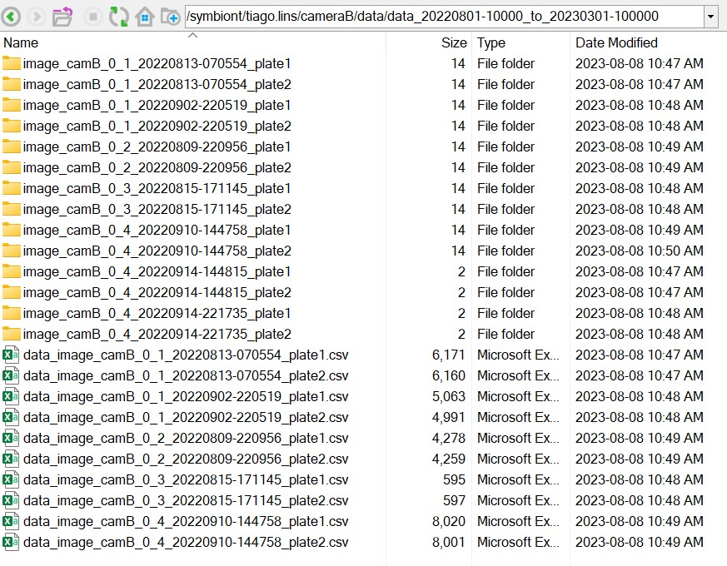

If you have a windows PC, a third-party software can also connect you to the server and run the script. One option is **Bitvise** [(https://www.bitvise.com/ssh-client-download)](https://www.bitvise.com/ssh-client-download), which also offers SFTP connection that allows you to see the files in the server in a more user-friendly way as shown above.

To connect, simply fill out the client window with your information similar to what is shown below:

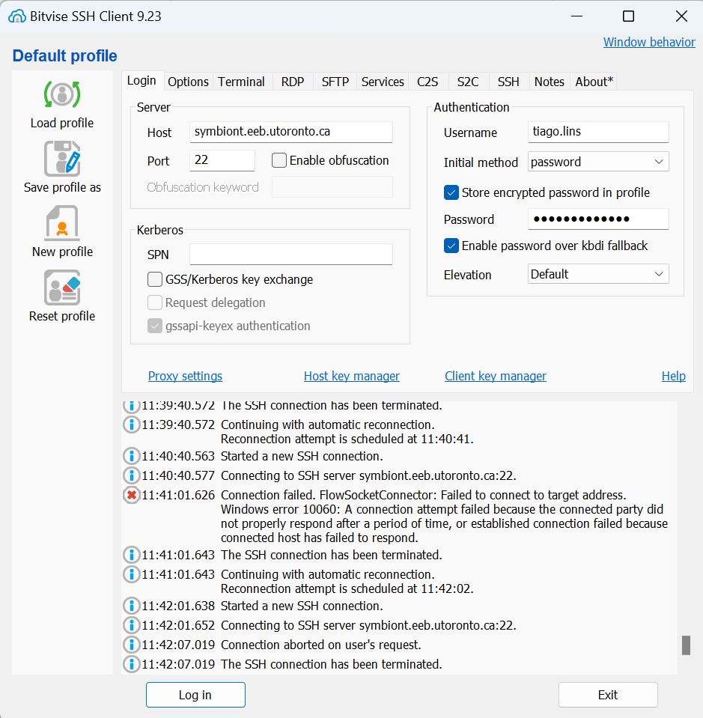

Click **Log in** and. Once you successfully logged into the server, click on **New SFTP window** (see below).

This will allow you to drag and drop files from and to the server into and from your local computer.

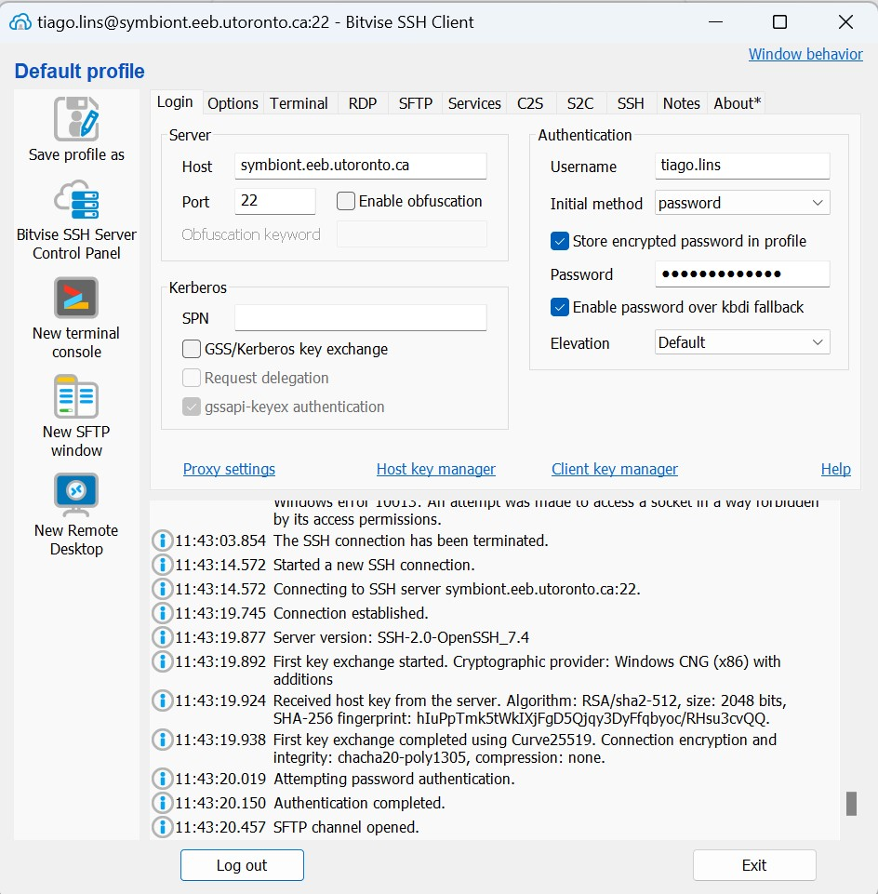

To run the script, click on **New terminal console** toopen the terminal and follow the same steps in **Running the script** below.

Raspberry Pi Board (when not in operation)

# Installation

1. Open the terminal window by clicking on the icon on the upper left side



1. Once opened, write “expect model_upload.exp” as shown below, and click enter/return on your keyboard

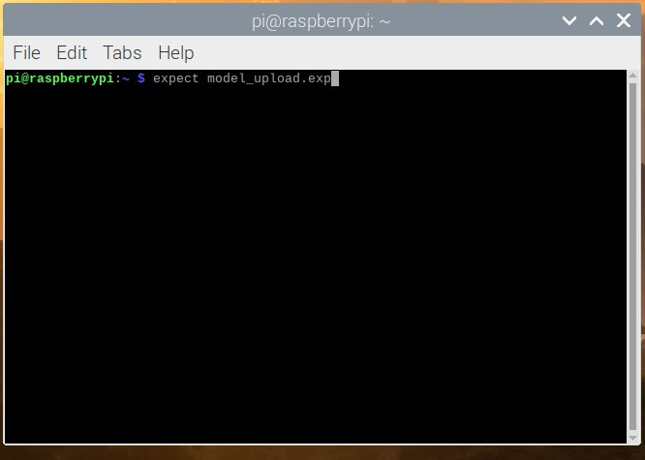

1. You will be prompted to write your username, password and address of where the **models** folder is stored, as shown below (note that your password won’t show up as you type). Click enter/return when done

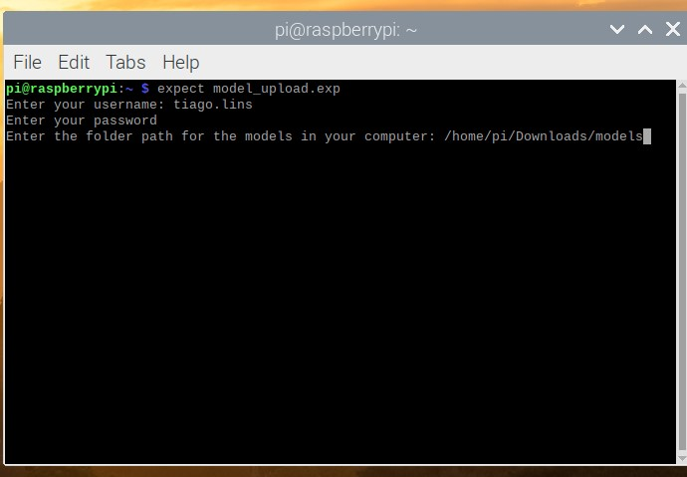

1. The terminal will automatically upload the model files into the server under your account. Wait until all files are uploaded, as shown below:

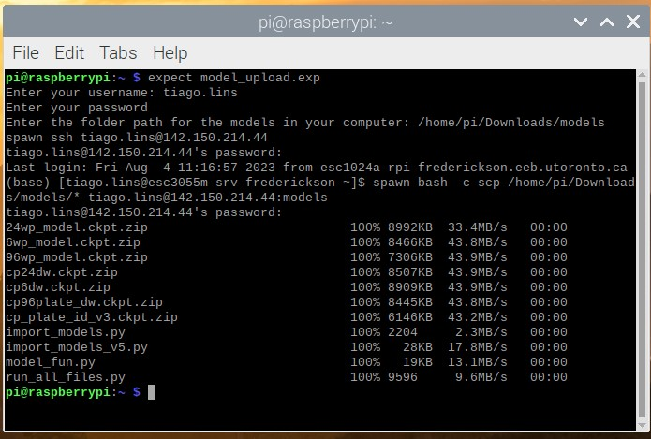

Once installed into the server under your username, you don’t need to repeat this step again, and simply run the script as described below

# Running the script

1. Now, connect directly to the server in the terminal by typing

“ssh <USERNAME>@symbiont.eeb.utoronto.ca”, where you should replace <USERNAME> with your assigned username, as shown below:

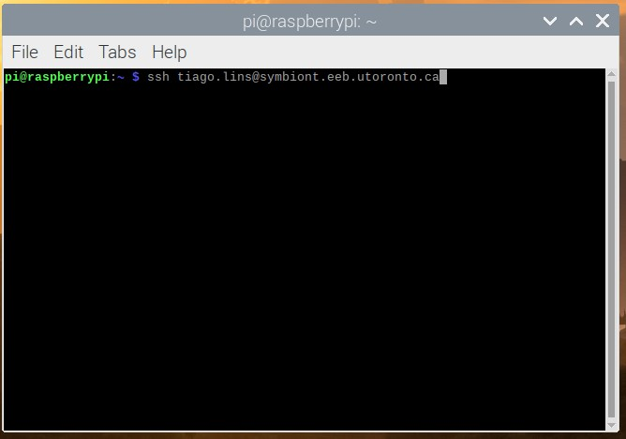

1. Now, we need to activate the environment with the required libraries. To do this, first type “cd

/symbiont/apps/miniconda3/condabin/” and press enter/return key

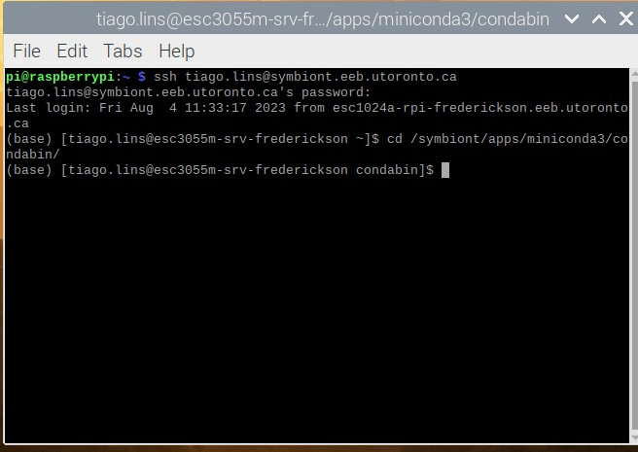

1. Then type “conda activate TF1”, and press enter/return

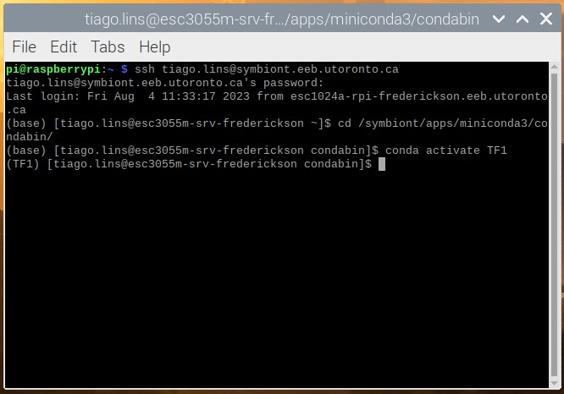

1. Now, type “cd” and press enter/return
2. Then type “cd models” and press enter/return
3. Now, to run the script, type “python run_all_files.py” and press enter/return key

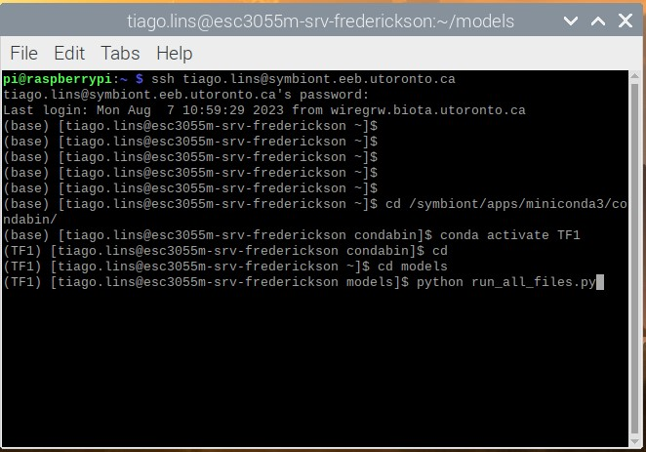

1. Several warnings will show up as you upload the models into the server. This is normal. Wait until all models are uploaded and you are prompted to enter your inputs

1. You will be asked the following questions. Enter the answer one by one.

* Please enter the directory name: [enter the path of where the image are stored in the server. For me, it is /symbiont/tiago.lins/cameraA]
* Please enter the start date as yyyymmdd-hhmmss (i.e. 20230705-100000 for July 5th, 2023 at 10 am): [Each image file should have a date on its name. Enter the earliest date you want to be processed using a format like this: 20220801-100000]
* Please enter the end date as yyyymmdd-hhmmss (i.e. 20230705-120000 for July 12th, 2023 at 10 am): Enter the latest date you want to be processed using a format like this: 20220801100000]
* Override plate identifier? (No, 96, 24, 12, 6): [In case you want the script to identify the plate type, write “no”; otherwise write the desired plate type]

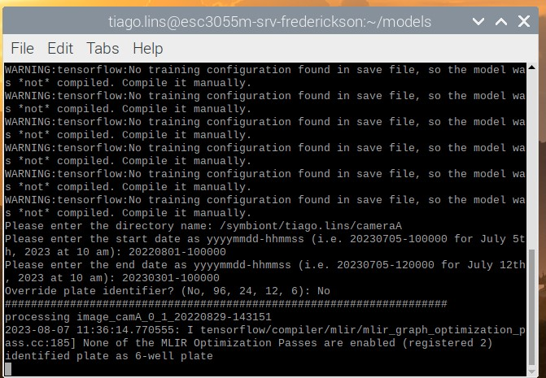

Once you press enter, the script will start processing the images. A **data** folder will be created on the same folder. Within the data folder, there will be a **data_<date_start>_to_< date_end>** folder with the results for your run. To navigate through these directories, use “cd <directory>”, “ls” commands to go to a new directory and to view the content in a directory, respectively.